Asynchronous Software
Department: | SSMS Extensions
Document Title: | SQL Shortcuts Installation & User Guide
Author: | Bert O’Neill
Date: | 27-June-2026
Version | 1.0
SharePoint
Document Goals | Provide a high-level overview, on how to install and use (SSMS) SQL Shortcuts extension.

Installation & User Guide

Revision History

Date(d/m/y) | Version | Description | Author
27/06/2026 | 1.0 | Initial draft | Bert O’Neill

Contents
1. Revision History 2
2. Introduction 4
2.1. Purpose 4
2.2. Scope 4
3. Installation 5
4. User Guide 5
5. Definitions, Acronyms, and Abbreviations 5

Introduction
This document provides a high level overview of the technologies and components that will be incorporated into a new architecture for processing sequestration data. It explains how a processor can securely update records without duplicating work by other processor’s (concurrency issue), delegate work and restricting who can update records based on their role. Plus, moving away from an Access\Excel based application and consolidating existing process flows with new data flows into a single web portal / dashboard.
This document provides a high-level description of the goals and aspirations that the new application plans to achieve.

Purpose
The Product Architecture Document (PAD) provides a comprehensive architectural overview of the newly proposed web sequestration portal. It presents an architectural view to depict data flow between the various components. It is intended to capture and convey the significant architectural decisions which have been made on the system.

Scope
The scope of this PAD is to convey the architecture of the online reporting application.

Installation

User Guide

Localized

Arabic
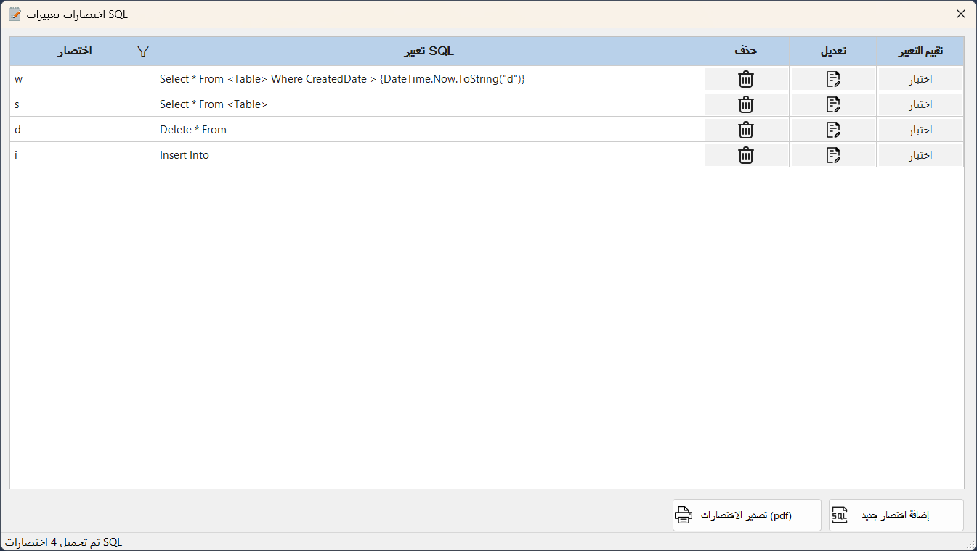

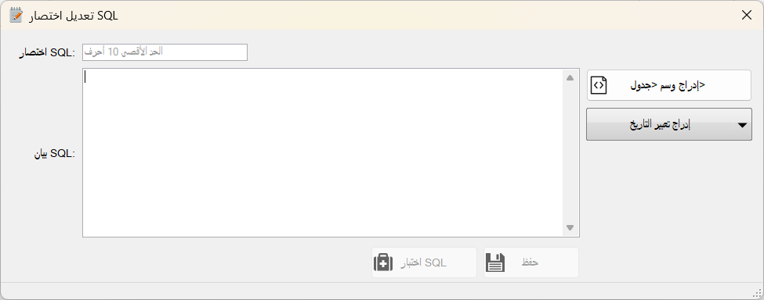

Definitions, Acronyms, and Abbreviations
Acronyms | Definition
SQL | Structured Query Language
CRUD | Create Retrieve Update Delete



